Easy Read

Survey

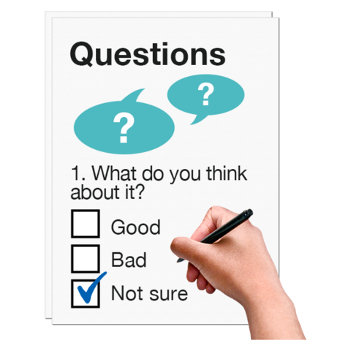

This is an easy read version of the Women in Sport Survey.

About this survey

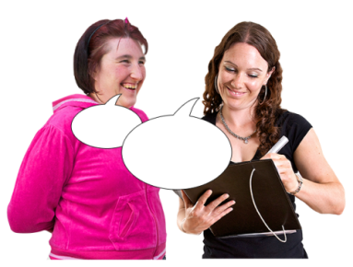 | We want to know about the sessions you have been to.
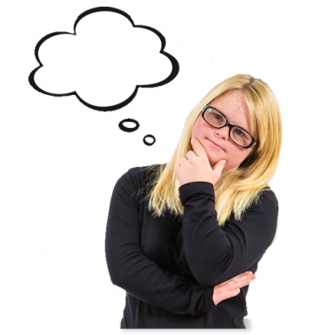 | We want to know:  - Why you went to the sessions  - What you thought of the sessions  - Why you kept going to the sessions

Filling in this survey

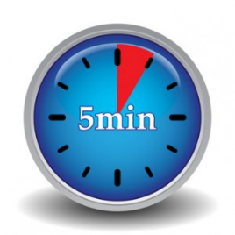 | This survey should take about 5 minutes to fill in.
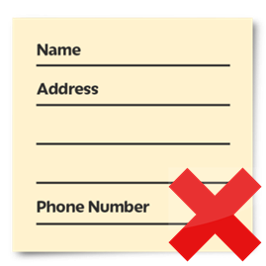 | You do not have to tell us your name, phone number or email address
 | If you have any questions about the survey or you want to find out more please email.

About the sessions you went to

- How did you find out about the sessions? Tick 1 box.

A friend or someone else | ☐
website | ☐
Facebook page | ☐
Twitter | ☐
Instagram | ☐
Newspaper | ☐
Poster or leaflet | ☐
Another way | ☐
Please tell us how in the box below:

- Why did you decide to go to a session? Tick your top 3 reasons.

I wanted to get fitter and healthier. | ☐
I wanted to change the way my body looks or feels. | ☐
I thought being more active would help me to feel good about myself. | ☐
I thought being more active would help me feel better about my life. | ☐
I went with a friend or someone from my family. | ☐
I thought the session would help with my health condition. | ☐
I hoped that going to a session would help me to feel more independent. | ☐
I wanted to meet new people. I wanted to make new friends. | ☐
I wanted to try something fun. | ☐
I wanted to try something different. Or I wanted to learn something new. | ☐
A different reason. | ☐
Please tell us your reason in the box below:

- Let us know what you thought about the sessions you have been to. Tick 1 answer box for each question.
Did you feel good at your first session?

No, definitely not | No, not really | Not sure | Yes, a bit | Yes, definitely
☐ | ☐ | ☐ | ☐ | ☐

Did you feel welcome at the sessions?

No, definitely not | No, not really | Not sure | Yes, a bit | Yes, definitely
☐ | ☐ | ☐ | ☐ | ☐

Did the instructor explain the activity well? Did they make you feel relaxed?

No, definitely not | No, not really | Not sure | Yes, a bit | Yes, definitely
☐ | ☐ | ☐ | ☐ | ☐

Did you feel that going to a session gave you some time for yourself?

No, definitely not | No, not really | Not sure | Yes, a bit | Yes, definitely
☐ | ☐ | ☐ | ☐ | ☐

Could you take part in the activity even if you had never done it before? Or if you had not done much exercise before? Or if you have a disability, health problems or long term illness.

No, definitely not | No, not really | Not sure | Yes, a bit | Yes, definitely
☐ | ☐ | ☐ | ☐ | ☐

Did you feel that doing the activity has made a difference to you?

No, definitely not | No, not really | Not sure | Yes, a bit | Yes, definitely
☐ | ☐ | ☐ | ☐ | ☐

Was the session easy to get to?

No, definitely not | No, not really | Not sure | Yes, a bit | Yes, definitely
☐ | ☐ | ☐ | ☐ | ☐

- Did you enjoy the session you went to? Tick 1 box.

No, definitely not | No, not really | Not sure | Yes, a bit | Yes, definitely
☐ | ☐ | ☐ | ☐ | ☐
- Let us know how you felt after going to the sessions. Tick 1 answer box for each question.

Did you feel part of a group with the other people that went to the sessions?

No, definitely not | No, not really | Not sure | Yes, a bit | Yes, definitely
☐ | ☐ | ☐ | ☐ | ☐

Did other women in the sessions make you feel like you wanted to get more active? Or see what you could get out of the session?

No, definitely not | No, not really | Not sure | Yes, a bit | Yes, definitely
☐ | ☐ | ☐ | ☐ | ☐

Did you feel included and valued?

No, definitely not | No, not really | Not sure | Yes, a bit | Yes, definitely
☐ | ☐ | ☐ | ☐ | ☐

Did your instructor help you think about how well you had done at the sessions?

No, definitely not | No, not really | Not sure | Yes, a bit | Yes, definitely
☐ | ☐ | ☐ | ☐ | ☐

Did your family or friends encourage you to go to the sessions?

No, definitely not | No, not really | Not sure | Yes, a bit | Yes, definitely
☐ | ☐ | ☐ | ☐ | ☐

Were you told how you could get even better at the activities?
No, definitely not | No, not really | Not sure | Yes, a bit | Yes, definitely
☐ | ☐ | ☐ | ☐ | ☐

- Since going to your first session, how active are you? Tick 1 box.

I am less active now than I was before my first session. | ☐
I am more active now than I was before my first session. | ☐
I am about as active now as I was before my first session. | ☐

- What difference has going to the sessions made to you? Tick the top 3 that you agree with.

I have made more friends since going to the sessions. | ☐
I feel fitter and more active than before I started going to the sessions. | ☐
I feel better. I do not feel as stressed. | ☐
I feel part of my community. I do not feel as lonely. | ☐
I have more confidence. | ☐
I feel more independent. | ☐
Going to the sessions has helped me reach my goals. | ☐
I feel good about looking after myself. | ☐
I do not agree with any of the above. | ☐

- Has going to the sessions made any other differences to you and your life? Please tell us about these in the box below.

- Do you think you will keep going to the sessions?

No, definitely not | No, not really | Not sure | Yes, a bit | Yes, definitely
☐ | ☐ | ☐ | ☐ | ☐

- Please tell us in the box below what we could change or make better to keep you going to the sessions.

Finishing the survey
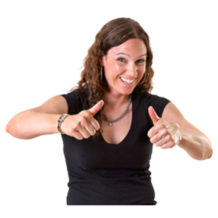 | Thank you for filling in our survey.
 | The information we collect will help us to understand how to help more women Get Out and Get Active.

